CS 254 Final Project Proposal
FarmerHub AI: An Intelligent Decision Support System for Smallholder Farmers in Ghana
Team: Louisa-Lois Adjoka · Daniel Ekpale · Chrishelle Wiafe · Kwasi Bekae Ackonor

1. Problem Statement and Motivation
Smallholder farmers in Ghana rely heavily on personal experience and fragmented information, facing challenges such as unpredictable weather, crop disease, and inefficient irrigation. Existing digital tools each solve a single problem, forcing farmers to juggle multiple apps. FarmerHub AI proposes a single decision-support platform that monitors farm conditions, predicts risks, and recommends actions, combining machine learning, search, and (as a stretch) NLP into one assistant that supports rather than replaces farmer expertise.
Using the course's agent framework: Performance = yield improvement and loss reduction; Environment = the farm; Actuators = recommendations and alerts sent to the farmer; Sensors = uploaded leaf photos, weather API data, and farm profile inputs. The environment is partially observable, stochastic, dynamic, and sequential because weather conditions, crop health, and pest populations change over time while the agent has incomplete knowledge of the farm's current state. FarmerHub is best classified as a model-based, learning agent because it maintains an internal representation of farm conditions, learns from historical data, and continuously updates recommendations as new information becomes available.

2. Proposed Solution
FarmerHub AI lets a farmer register basic farm details and receive tailored recommendations. Given the five-week timeline, the team commits to three core AI modules plus an integration dashboard, with three additional modules pursued as stretch goals if time allows.
Module | Description | Status
Yield Prediction | Random Forest Regressor predicts harvest yield from weather, soil, and crop data because it performs well on structured tabular datasets and captures nonlinear relationships without extensive feature engineering. | CORE
CNN Disease Detection | CNN classifies leaf photos as healthy/diseased and suggests treatment. An SVM classifier will serve as a fallback model if CNN training cannot be completed within the project timeline. | CORE
A* Route Optimization | The search problem is formulated with farm locations as states, movement between locations as actions, Euclidean distance as an admissible heuristic (it never overestimates true cost), and travel time as the path cost, generating efficient inspection/irrigation routes that prioritize high-risk areas. | CORE
Farm Health Dashboard | The Farm Health Score is computed by combining disease probability, predicted yield, weather conditions, and irrigation status into a single indicator that allows farmers to quickly assess the overall condition of their farms. | INTEGRATION
AI Farm Assistant | LLM/RAG chatbot answering farming questions from trusted local sources. | STRETCH
Weather-Based Decision Support | Rule-based planting/irrigation alerts layered on live weather data. | STRETCH
Farm Zone Clustering (K-Means) | Groups farm zones with similar disease and yield characteristics, allowing the route planner to prioritize high-risk clusters. | STRETCH

Scope note: Our three core deliverables are Yield Prediction, CNN Disease Detection, and A* Route Optimization, integrated through the Farm Health Dashboard. The AI Farm Assistant, Weather-Based Decision Support, and K-Means Farm Zone Clustering are stretch goals pursued only after the core modules are working, consistent with the guide's recommendation to scope realistically.

System Architecture:
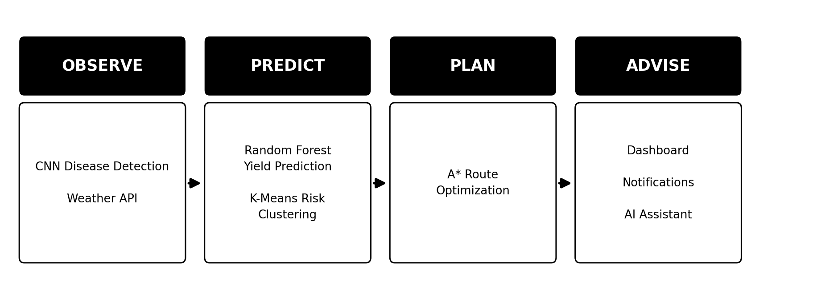

Detailed Input to Output Flow:
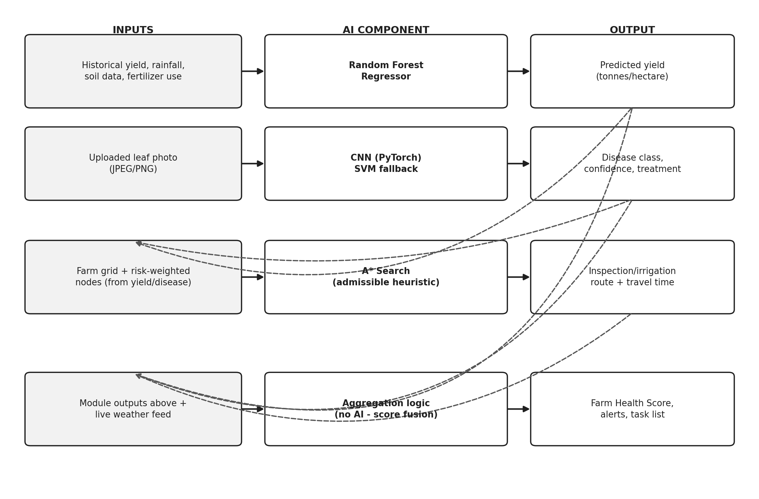
Solid arrows show each module's own input to AI component to output flow. Dashed arrows show cross-module connections: Yield Prediction and CNN Disease Detection outputs feed into A*'s risk-weighted routing and into the Farm Health Dashboard, alongside the live weather feed.

3. AI Techniques
Technique | Application | Status
Supervised ML (Random Forest) | Yield prediction | CORE
Computer Vision (CNN) | Leaf disease classification (SVM fallback) | CORE
Search (A*) | Farm task / irrigation route planning | CORE
Unsupervised ML (K-Means) | Farm zone / risk clustering | STRETCH
NLP (LLM + RAG) | Conversational farm assistant | STRETCH

4. Data Sources and Tools
Module | Data Source | Key Tools
Yield Prediction | Kaggle West/Sub-Saharan Africa datasets, or FAOSTAT's Ghana profile | Pandas, NumPy, scikit-learn
CNN Disease Detection | PlantVillage (baseline); Zindi Ghana Crop Disease images (robustness check) | PyTorch, torchvision, OpenCV/Pillow
A* Route Optimization | None (synthetic farm grid generated in Python) | Python heapq
Dashboard | OpenWeatherMap API (free tier) | Flask/FastAPI, React/Flutter
K-Means (stretch) | Existing module outputs; no new external data | scikit-learn (KMeans, StandardScaler)
AI Farm Assistant (stretch) | MoFA extension PDFs | pypdf, ChromaDB, LLM API
Weather Support (stretch) | Same OpenWeatherMap feed | requests, rule-based logic

5. Expected System Performance
Module | Evaluation Metric(s)
Yield Prediction | Mean Absolute Error (MAE), Root Mean Squared Error (RMSE)
CNN Disease Detection | Accuracy, Precision, Recall, F1-score
A* Route Optimization | Travel distance / time saved vs. naive routing
Stretch modules | Response quality and usability via informal user testing

6. Ethical Considerations
The system will follow the AI Ethics Audit framework introduced in the course. Farmers will be told recommendations are advisory, not guaranteed; personal farm data will be handled responsibly; datasets will be chosen to minimize bias where possible; and predictions will be presented with brief explanations rather than as black-box outputs.

7. Team Roles
Member | Core Focus | Key Responsibilities
Louisa-Lois Adjoka | PM, Frontend & Integration | Coordinates timeline; builds the Farm Health Dashboard (React/Flutter) consolidating all core module outputs; owns documentation (README, report). Stretch: Weather-Based Decision Support, layered onto the dashboard's existing weather feed.
Kwasi Bekae Ackonor | CV & Disease Detection (Core) | Sources/preprocesses PlantVillage data; builds and fine-tunes the CNN; evaluates with accuracy/precision/recall/F1. No stretch goal assigned, to protect focus on the project's highest-risk core module.
Chrishelle Wiafe | ML & Yield Prediction (Core) | Cleans/engineers yield-weather-soil features; trains and tunes the Random Forest Regressor; evaluates with MAE/RMSE; leads performance reporting. Stretch: K-Means Farm Zone Clustering, combining her yield-risk output with Kwasi's disease-risk output.
Daniel Ekpale | Search, Backend & AI Assistant | Implements A* routing (grid, heuristic, cost function); builds the Flask/FastAPI backend; leads testing/deployment. Stretch: AI Farm Assistant (LLM/RAG), integrated into his existing backend.

All members contribute to the AI Ethics Audit for their respective modules, GitHub commits, integration testing, and the final oral presentation.

8. Milestone Plan
Week | Dates | Key Activities
10 | Jul 20–24 | Finalize datasets/APIs; design system architecture; set up GitHub repo; build UI prototype.
11 | Jul 27–31 | Sprint 1: build working baselines for the three core modules (yield, CNN, A*).
12 | Aug 3–7 | Sprint 2: integrate core modules into the Dashboard; begin evaluation; attempt stretch goals (K-Means, AI Assistant, Weather Support) if ahead of schedule; informal progress demo.
13 | Aug 10–14 | Finalize implementation/evaluation; ethics & fairness audit; polish report, README, and slide deck.

Expected Outcome
FarmerHub AI will deliver a working prototype combining supervised machine learning, computer vision, and search-based planning into one Ghana-focused decision-support platform, with clustering, a conversational AI assistant, and weather-based rules pursued as stretch enhancements, demonstrating multiple AI concepts from CS 254 within a realistic five-week scope.

